3GPP TSG-RAN WG1 #125 R1-2604045
Dalian, China, May. 18th ~ 22nd, 2026
Agenda Item: 10.8.3
Source: InterDigital, Inc.
Title: 6GR ISAC Waveform and Frame Structure
Document for: Discussion and Decision

Introduction
The Study on 6G Radio (FS_6G_Radio) includes the following objective for Sensing [1]:
- Sensing – Studies to be based on use cases and associated requirements, as defined in [TR38.914]
- PHY functions and procedures for sensing technology (e.g., waveform. reference signals, measurement feedback, etc…) [RAN1, RAN4]
- Evaluate sensing performance and if necessary, extend channel modelling, for the selected use cases [RAN1]
- Aspects of integration with communication services [RAN1]
- higher layer procedures and protocol aspects [RAN2]
- RAN4 aspects of sensing including RF, coexistence, and testability in coordination with other WGs [RAN4]
Note: RAN1 identify detailed requirements, if triggered by TSG RAN
The RAN1 scope of the study includes sensing-related PHY functions and procedures, evaluation of sensing performance, and aspects of integration with communication. Under this scope, AI 10.8.3 covers potential enhancement based on communication waveform, potential new waveform, frame structure, and corresponding analysis on performance benefit and impact in terms of integration with communication:

10.8.3 Waveform and frame structure
Note 1: Including proposals for potential enhancement based on communication waveform (e.g., low PAPR waveform enhancement, longer CP length, larger SCS etc.), potential new waveform, frame structure, and corresponding analysis on performance benefit and impact in terms of integration with communication.
Building on the RAN1#124bis agreements that CP-OFDM and the 6GR communication frame structure are the starting points for 6G ISAC waveform and frame-structure study, this contribution provides views on topics for RAN1#125 discussion, including ISAC-specific enhancements, candidate waveform/frame-structure mechanisms, and common evaluation assumptions.

Study Principles
Signal design is a fundamental aspect of an ISAC system, directly impacting the performance of sensing and communication services. The signal design factors include waveform, numerology, reference signal (RS), and radio resources. The existing signal design approaches can be broadly grouped into sensing-centric design, communication-centric design, and multiplexed signal design. Sensing-centric designs are based on radar waveforms such as Linear Frequency Modulation (LFM) and Frequency-Modulated Continuous-Wave (FMCW), which exhibit strong sensing characteristics such as auto-correlation and cross-correlation. Communication-centric designs, on the other hand, rely on waveforms such as OFDM to maximize data-rate-oriented communication performance. Multiplexing techniques can be used to strike trade-offs between communication and sensing performance, though this introduces additional system complexity.
To enable sensing capabilities, existing NR waveforms can be reused. CP-OFDM’s inherent properties, such as high time-frequency resolution and robustness to multipath, make it well-suited for extracting sensing measurements from reflected and scattered signals. Additionally, CP-OFDM offers high flexibility in resource allocation across time, frequency, and spatial domains. This flexibility allows for dynamic configuration of sensing resources, allocating more bandwidth, time slots, or spatial beams based on sensing requirements. Consistent with this, the Rel-20 NR ISAC study [2] reuses existing DL NR waveform (CP-OFDM) and reference signals as baseline for evaluation. In addition, the Rel-20 NR ISAC framework includes sensing evaluation assumptions such as sensing resource usage, coherent processing interval (CPI), and time-frequency RE mapping. The NR ISAC study provides a useful reference for the sensing waveform and frame-structure study in AI 10.8.3.
On the communication side, the ongoing 6GR waveform and frame-structure studies have already established relevant starting points [3][4]. For waveform, CP-OFDM is supported as the basis waveform for downlink, and CP-OFDM and DFT-s-OFDM are supported as the basis waveforms for uplink, while enhancements to these baseline waveforms and other OFDM-based waveforms are not precluded. For frame structure, the NR frame structure is used as the starting point, including normal CP, 12-subcarrier RB, 10 ms radio frame, 10 subframes of 1 ms, same symbol duration/normal CP length/boundary as NR for a given SCS and symbol, and 14 consecutive symbols per slot for normal CP. The same agreement set also states that numerologies for sensing are up to the sensing agenda discussion. Since AI 10.8.3 includes the impact of ISAC waveform and frame structure in terms of integration with communication, these communication-side starting points should be explicitly considered in the 6G ISAC study.
At RAN1#124bis, it was agreed that CP-OFDM waveform as defined for 6GR is the starting point for 6G ISAC waveform study, that 6GR communication frame structure is the starting point for 6G ISAC frame-structure study, and that CP-OFDM is used as the benchmark for evaluating the benefits of sensing waveforms [5].
Agreement:
CP-OFDM waveform as defined for 6GR is the starting point for 6G ISAC waveform study.
Study on enhancements on CP-OFDM or other waveforms is not precluded.

Agreement:
6GR communication frame structure is the starting point for 6G ISAC frame structure study, in at least the following aspects.
- Frame/sub-frame/slot/symbol structure
- CP length
- SCS
Enhancements on frame structure/above aspects are not precluded.

Agreement:
CP-OFDM is used as the benchmark for evaluating the benefits of sensing waveforms.
Accordingly, the design principles for AI 10.8.3 should start from the agreed baseline and benchmark, and should treat enhancement or evolution beyond the starting points as something to be justified, not assumed. In particular, the fact that enhancements are “not precluded” should be understood in a gap-based way: waveform and/or frame-structure enhancements can be studied relative to the agreed starting points, but further consideration of such enhancements should be limited to cases where the baseline CP-OFDM waveform and/or 6GR communication frame structure show limitations or gaps in meeting the relevant sensing requirements/KPIs or communication-integration requirements for the considered sensing mode, scenario, and operating assumptions.
Observation 1: For AI 10.8.3, the agreed CP-OFDM waveform and 6GR communication frame structure should be treated as the starting points for 6G ISAC waveform and frame-structure study, and CP-OFDM should be used as the benchmark for waveform evaluation. Therefore, further consideration of enhancements beyond the agreed starting points should be justified by identified limitations or gaps of the baseline in meeting the relevant sensing requirements/KPIs or communication-integration requirements for the considered sensing mode, scenario, and operating assumptions.
Proposal 1: RAN1 should study 6G ISAC-specific waveform and/or frame-structure enhancements relative to the agreed CP-OFDM waveform and 6GR communication frame-structure starting points. Further consideration of such enhancements should be limited to cases where the agreed starting points show limitations or gaps in meeting the relevant sensing requirements/KPIs or communication-integration requirements for the considered sensing mode, scenario, and operating assumptions.
Since CP-OFDM and the 6GR communication frame structure are the agreed starting points, comparison of candidate enhancements should use aligned assumptions on sensing resources, observation interval/CPI, power/energy, receiver processing, channel/interference, and communication integration. Otherwise, apparent gains may be due to different assumptions rather than the candidate enhancement itself. The existing 6GR waveform characterization table can be reused for waveform candidates with sensing-specific additions where relevant.
Agreement:
Extend the RAN1#123 endorsed table to characterize each (waveform) proposal as a potential RAN1 observation as follows to cover also impacts to transmitter and receiver processing operation:
 | Description
Name of the proposal
Motivation of the proposal | E.g. TN, NTN, ISAC, etc…
Applicable link direction | DL/UL/both
Enhancement to CP-OFDM? | No/Yes
Enhancement to DFT-s-OFDM? | No/Yes
Additional OFDM-compatible waveform? | No/Yes
Target channel(s)/signal(s) | PDCCH/PDSCH/PUCCH/PUSCH/xxx
Target modulation
Motivation / use case | Improved spectral efficiency, …
Key Metric / KPI | Spectral efficiency, …
Key spec impact foreseen
MRSS compatibility | Please explain
Multiplexing/coexistence with other waveforms | Please explain
Multi-user multiplexing | Please explain
MIMO compatibility | Please explain
Implementation/operation impacts on transmitter processing | Please explain
Implementation/operation impacts on receiver processing | Please explain

Observation 2: Since CP-OFDM and the 6GR communication frame structure are the agreed starting points, fair comparison of candidate enhancements requires alignment on key comparison dimensions, including sensing resources, observation interval/CPI, power/energy, receiver processing, channel/interference, and communication integration.
Proposal 2: RAN1 should compare 6G ISAC waveform and frame-structure candidates using a common comparison basis, including at least:
- sensing mode and scenario;
- sensing signal/resource configuration;
- RE mapping and sensing resource ratio/overhead;
- observation interval/CPI;
- numerology, bandwidth, and transmit power/energy;
- receiver processing;
- channel and interference model;
- communication integration impact, including coexistence and multiplexing.

As agreed at RAN1#124bis [5], companies are encouraged to provide views to RAN1#125 on the necessity, pros/cons, and metrics of LLS and/or SLS, and on the pros/cons/metrics of theoretical waveform-characteristics analysis, for evaluation of ISAC waveform and/or integration with communication.
In our view, these evaluation methods are complementary. Theoretical waveform-characteristics analysis can be useful to study waveform properties such as PAPR, ambiguity-function behavior, side-lobe characteristics, correlation properties, and spectral confinement. However, such analysis does not by itself capture sensing performance under channel, receiver-processing, and interference assumptions. LLS can be used to evaluate point-to-point sensing performance under defined channel and receiver assumptions, while SLS can be considered where system-level sensing performance, overhead, or communication-integration impact needs to be assessed.
Observation 3: Theoretical waveform-characteristics analysis is useful as one component of 6G ISAC waveform and frame-structure study, but it is not sufficient on its own for evaluating sensing waveform or frame-structure candidates. Evaluation should also include LLS and, where justified, SLS, in order to assess sensing performance under defined channel and receiver assumptions.
Proposal 3: RAN1 can use theoretical waveform-characteristics analysis as one component of 6G ISAC waveform and frame-structure study, but not as the only basis for evaluating sensing waveform or frame-structure candidates. Link-level study should be used to evaluate point-to-point sensing performance under defined channel and receiver assumptions, and system-level study should be considered where system-level sensing performance, overhead, or communication-integration impact is to be assessed.
Where LLS and/or SLS is used, the metrics should be tied to actual sensing performance and communication integration. Relevant metrics include delay/range accuracy, Doppler/velocity accuracy, missed-detection probability and false-alarm probability where applicable, robustness to SNR, Doppler, timing offset, and frequency offset where relevant, sensing overhead/resource efficiency, and communication impact including coexistence and multiplexing effect.
Observation 4: For LLS and/or SLS evaluation of waveform and frame-structure candidates, the metrics should be tied to actual sensing performance and communication integration, rather than being limited to waveform-characteristics quantities alone. Relevant metrics include sensing accuracy, detection reliability, robustness, sensing overhead/resource efficiency, and communication impact.
Proposal 4: For LLS and/or SLS evaluation of waveform and frame-structure candidates, RAN1 should study metrics including at least:
- delay/range accuracy;
- Doppler/velocity accuracy;
- missed-detection probability, where applicable;
- false-alarm probability, where applicable;
- robustness to SNR, Doppler, timing offset, and frequency offset where relevant;
- sensing overhead/resource efficiency;
- communication impact, including coexistence and multiplexing effect.

Where theoretical waveform-characteristics analysis is used in waveform study, the metrics should be made explicit. Such metrics are useful for examining waveform properties related to transmit-power efficiency, spectral containment, ambiguity behaviour, sidelobe characteristics, correlation properties, and unambiguous sensing support.

Relevant metrics include PAPR, ACLR/OOBE, ambiguity-function main-lobe and side-lobe characteristics, PSLR, ISLR, auto-correlation and/or cross-correlation characteristics, and maximum unambiguous delay/range and Doppler/velocity where applicable. These metrics are useful because they characterize waveform properties that often motivate sensing-oriented waveform enhancement or the study of additional waveform candidates.

Observation 5: Theoretical waveform-characteristics analysis for sensing waveform study may include multiple candidate metrics related to PAPR, spectral containment, ambiguity behaviour, correlation properties, and unambiguous sensing support.

Proposal 5: For theoretical waveform-characteristics analysis, RAN1 should study metrics including at least:
- PAPR;
- ACLR/OOBE;
- ambiguity-function main-lobe and side-lobe characteristics;
- PSLR;
- ISLR;
- auto-correlation and/or cross-correlation characteristics;
- maximum unambiguous delay/range and Doppler/velocity, where applicable.

Waveform
For AI 10.8.3, the 6G ISAC waveform study should build on the agreed CP-OFDM starting point. In this context, candidate study should include both sensing-oriented enhancements to CP-OFDM-based sensing signals/resources and, where relevant, additional waveform/signal candidates. For each candidate, it should be clear how the sensing signal/resource is generated, shaped, mapped, processed, and multiplexed with communication, and how it is introduced relative to CP-OFDM. The benefit of any enhancement or additional candidate should be evaluated against the CP-OFDM reference under aligned sensing requirements/KPIs, sensing modes, scenarios, and operating assumptions.
Baseline-compatible waveform enhancement
Enhancements based on the communication waveform may include bounded changes that remain compatible with the baseline CP-OFDM framework while addressing sensing-related requirements. Such enhancements should be studied in terms of necessity/benefit and applicable scenarios, since different sensing modes and scenarios may stress different waveform properties.
From the perspective of the agreed CP-OFDM waveform starting point, relevant enhancement aspects may include PAPR, ACLR/OOBE, ambiguity-function characteristics, auto-/cross-correlation characteristics, sensing RS overhead, resilience to ISI/ICI, full-duplex-related operation, and time-domain and/or frequency-domain processing of sensing signals/resources. These aspects correspond to different sensing objectives, such as transmit-power efficiency, spectral containment, delay/Doppler discrimination, target separability, resource efficiency, robustness to delay/Doppler spread, and coexistence with communication.
One possible class of CP-OFDM-based waveform enhancement is time-domain and/or frequency-domain processing of sensing signals/resources. In communication, shaping, filtering, coding, and related signal processing can be used to improve signal reception under channel impairments. Similarly, in sensing, the sensing RS/resource may be shaped or transformed so that the reflected signal is easier to detect and estimate. Such processing may be applied at the transmitter before or during OFDM modulation, with corresponding receiver-side processing, while preserving compatibility with the baseline CP-OFDM waveform/RF framework where applicable.
Observation 6: From the perspective of the agreed CP-OFDM waveform starting point, sensing-oriented waveform enhancements should be studied in terms of both necessity/benefit and applicable scenarios.
Proposal 6: RAN1 should study the necessity/benefits and the applicable scenarios at least for the following enhancements from perspective of CP-OFDM waveform for 6G ISAC:
- Low PAPR
- Low ACLR/OOBE
- Ambiguity function characteristics
- Auto- or Cross-correlation
- Time-domain and/or frequency-domain processing of sensing signals/resources
- Low sensing RS overhead (e.g., guard band reuse)
- Resilience to ISI (Inter-Symbol Interference) and/or ICI (Inter-Carrier Interference)
- Full duplex operation
Note that pulse-type and FMCW/LFM-type sensing waveform/signal candidates are not included in the CP-OFDM enhancement proposal above, since they may imply a different sensing signal or waveform structure depending on the realization. Therefore, they are addressed separately as additional waveform/signal candidates. The CP-OFDM enhancement study in this section focuses on bounded enhancements to sensing signals/resources within, or closely related to, the agreed CP-OFDM waveform starting point.
Figure 1 provides an example of a bounded enhancement on top of baseline CP-OFDM reuse, where baseline IFFT-PRS case is compared with multiple transform-based configurations for range RMSE and velocity RMSE versus SNR. For the considered setup, the results indicate that transform-based processing on top of the baseline OFDM sensing waveform may improve the SNR operating region for sensing, with the achieved gain depending on the selected configuration and performance metric under consideration. The simulation assumes a subcarrier spacing of 120 kHz and an FFT size of 512. The reference signal considered is PRS with comb-4. In addition to the baseline OFDM processing, an additional processing layer is applied to the OFDM symbols carrying PRS for sensing operation. In particular, three wavelet functions are considered, denoted as WT-1, WT-2, and WT-3, which correspond to Battle-Lemarie wavelet of order 10, reverse biorthogonal spline wavelet, and discrete Meyer wavelet, respectively.

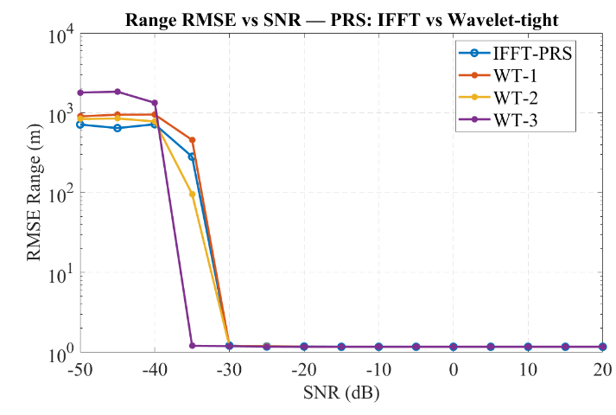 | 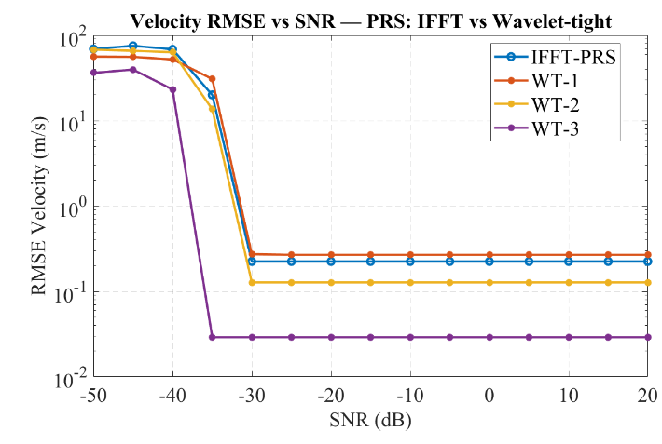
Figure 1: Example comparison of baseline CP-OFDM reuse and transform-based enhancement.
For time-domain and/or frequency-domain processing of sensing signals/resources, the study should further clarify how the processing is applied. In particular, the processing may be applied at the transmitter side, the receiver side, or both. It may be applied to sensing RS/sequence generation, RE/resource mapping, OFDM-symbol-level samples, and/or receiver-side sensing processing. Since the sensing receiver may need to apply corresponding processing, such as matched filtering, inverse transform, or correlation using the configured sensing signal/resource structure, the required receiver knowledge or configuration should also be considered. The study should also consider the impact on CP-OFDM compatibility, communication coexistence, and baseband implementation complexity.

Observation 7: Time-domain and/or frequency-domain processing of sensing signals/resources may provide sensing enhancement while remaining compatible with the baseline CP-OFDM RF chain. Such processing should be studied in terms of where it is applied, what receiver knowledge/configuration is required, and what impact it has on communication coexistence and baseband implementation complexity.

Proposal 7: For time-domain and/or frequency-domain processing of sensing signals/resources, RAN1 should study at least:
- where the processing is applied, e.g., transmitter side, receiver side, or both;
- whether the processing is applied to sensing RS/sequence generation, RE/resource mapping, OFDM-symbol-level samples, and/or receiver-side sensing processing;
- required receiver knowledge or configuration of the processing;
- impact on CP-OFDM compatibility, communication coexistence, and baseband implementation complexity.
Additional waveform/signal candidates
AI 10.8.3 also includes study of additional waveform candidates. In this context, pulse-type and FMCW/LFM-type sensing waveform/signal candidates are of particular interest. However, instead of discussing such candidates only in terms of whether they are “new waveforms,” it is important to clarify how they are introduced relative to the agreed CP-OFDM waveform starting point.
Additional waveform/signal candidates should therefore be studied relative to CP-OFDM reuse and CP-OFDM-based enhancements, under aligned sensing signal/resource and operating assumptions. Such study can clarify whether a different signal structure provides meaningful sensing gain, for which sensing modes/scenarios, and with what impact on communication integration. Relevant examples include chirp/LFM/FMCW-type signals and pulse/non-continuous waveform structures.
Chirp/LFM/FMCW-based signal structures may provide desirable sensing properties, such as low-PAPR or constant-envelope-like behaviour, favourable ambiguity/correlation characteristics, and robustness to certain impairments depending on the design and receiver processing. Pulse-type or non-continuous structures may also be relevant where sensing benefits are associated with time localization, guard-time handling, or dedicated sensing-resource operation.
For example, Figure 2 shows the ambiguity function of the baseline OFDM signal, while Figure 3 shows the ambiguity function of an OFDM signal multiplexed with chirp/LFM. For the considered setup, the ambiguity function with chirp/LFM exhibits a more concentrated and slanted main peak compared with the baseline OFDM case. This suggests different delay-Doppler discrimination and estimation behaviour, and the corresponding range-Doppler coupling and receiver-processing assumptions should be considered when interpreting the result.

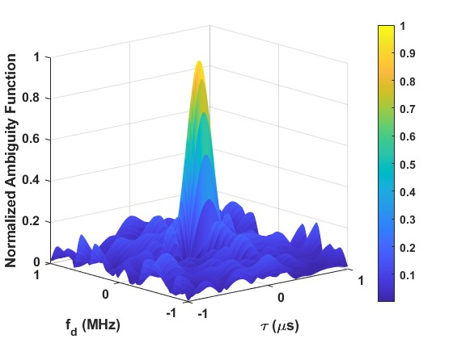 | 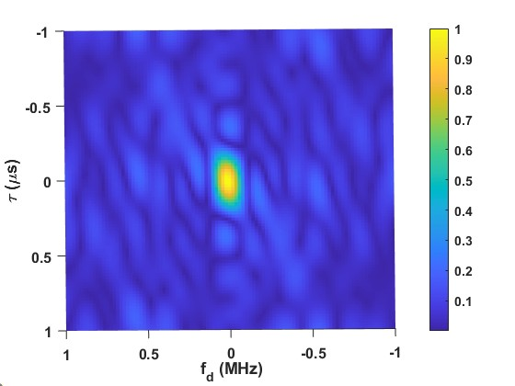
Figure 2: Ambiguity function for OFDM.
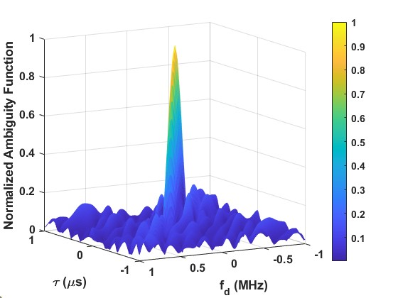 | 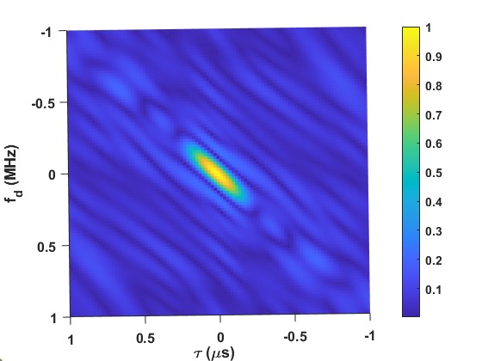
Figure 3: Ambiguity function for OFDM multiplexed with chirp/LFM.
For such candidates, the waveform/signal introduction method should be made explicit. In particular, the study should clarify whether the candidate is realized within CP-OFDM-based signal/resource design, multiplexed with CP-OFDM communication or sensing resources, or introduced through dedicated sensing resources where a dedicated waveform/signal structure is assumed. The corresponding assumptions on RE mapping, CPI, overhead, coexistence, receiver processing, and communication impact should also be made explicit, since the sensing gain of an additional waveform/signal candidate cannot be interpreted independently of how it is introduced relative to the baseline CP-OFDM framework.
Observation 8: For pulse-type and FMCW/LFM-type sensing waveform/signal candidates, the method of introduction relative to the agreed CP-OFDM waveform starting point is a key study aspect, including whether the candidate is realized within CP-OFDM-based signal/resource design, multiplexed with CP-OFDM resources, or introduced through dedicated sensing resources.
Proposal 8: For pulse-type and FMCW/LFM-type sensing waveform/signal candidates, RAN1 should study how such candidates are introduced relative to the agreed CP-OFDM waveform starting point, including at least:
- realization within CP-OFDM-based signal/resource design;
- multiplexing with CP-OFDM communication or sensing resources;
- use of dedicated sensing resources where a dedicated waveform/signal structure is assumed.

For pulse-type and FMCW/LFM-type sensing waveform/signal candidates, multiple generation methods may be possible. Some methods remain closely tied to the baseline OFDM framework, while others assume a more dedicated sensing waveform/signal structure. For fair study, these alternatives should be made explicit and compared under aligned assumptions.
Possible methods include CP-OFDM-based generation using frequency-domain signal/resource design, CP-OFDM-based generation using large SCS, sequence-based generation such as enhanced ZC or chirp-like sequences, DFT-s-OFDM-based generation, and dedicated FMCW/LFM or FMBW generation where applicable. These alternatives differ in compatibility with the baseline communication waveform framework, required transmitter processing, receiver knowledge/processing, resource mapping, and coexistence impact. Therefore, it is useful to study them explicitly rather than treating pulse/FMCW/LFM as a single undifferentiated candidate class.

Observation 9: Pulse-type and FMCW/LFM-type sensing waveform/signal candidates may be generated using multiple methods, ranging from CP-OFDM-compatible signal/resource design to more dedicated sensing waveform/signal structures. These generation methods should be studied explicitly.

Proposal 9: For pulse-type and FMCW/LFM-type sensing waveform/signal candidates, RAN1 should study generation methods, including at least:
- CP-OFDM-based generation using frequency-domain signal/resource design;
- CP-OFDM-based generation using large SCS;
- sequence-based generation, e.g., enhanced ZC or chirp-like sequences;
- DFT-s-OFDM-based generation;
- dedicated FMCW/LFM or FMBW generation where applicable.

Additional aspects for study

Another important waveform-study aspect is whether waveform/signal properties for certain sensing modes should be left fully implementation-specific or should instead be studied for possible specification benefit. In particular, for TRP-TRP bistatic sensing, TRP monostatic sensing, and UE monostatic sensing, the waveform/signal assumptions may affect interoperability, resource/timing coordination, receiver knowledge, interference handling, reuse of the same waveform family across sensing modes, and coexistence with communication.
Therefore, it is premature to assume that waveform/signal aspects for these sensing modes are fully implementation-specific without further study. Instead, the potential benefits of specifying such aspects should be studied, especially where coordination between entities, coexistence with communication, or reuse across sensing modes is relevant. This is particularly important for TRP-TRP bistatic sensing, where multi-vendor interoperability and coordination can be more directly affected by waveform/signal assumptions.

Observation 10: For TRP-TRP bistatic sensing, TRP monostatic sensing, and UE monostatic sensing, waveform/signal assumptions may have specification relevance, including interoperability, resource/timing coordination, receiver knowledge, interference handling, reuse across sensing modes, and coexistence with communication.

Proposal 10: RAN1 should study the potential benefits of specifying waveform/signal aspects for TRP-TRP bistatic sensing, TRP monostatic sensing, and where UE monostatic sensing is studied, UE monostatic sensing, instead of assuming that the sensing waveform is fully implementation-specific. The study should consider at least interoperability, resource/timing coordination, receiver knowledge, interference handling, reuse of the same waveform family across sensing modes, and coexistence with communication.

In addition to sensing RS/resources, another possible direction is to study whether and under what conditions 6GR communication data can be used for sensing. This question is relevant because communication data may already occupy resources that could potentially be exploited for sensing, but it also raises issues such as receiver knowledge of the communication data/signal, data randomness, sensing reliability, and impact on communication reception.

One possible way to improve sensing reliability in such cases is to multiplex deterministic sensing components or sensing RS/resources with communication data, so that the communication data is not the only sensing-relevant component. This is particularly relevant in cases where the sensing signal is multiplexed with another deterministic structure, e.g., chirp-like or RS-based components, on shared resources. Therefore, the study should not be limited to whether communication data can be used at all, but should also address the conditions and mechanisms under which it can be used in a sensing-relevant way.

Observation 11: Use of 6GR communication data for sensing is an open waveform/signal study aspect whose applicability may depend on sensing mode, scenario, receiver knowledge, data randomness, communication impact, and the possibility of multiplexing deterministic sensing components or sensing RS/resources with the communication data.
Proposal 11: RAN1 should study whether and under what conditions 6GR communication data can be used for sensing. The study should consider at least applicable sensing modes and scenarios, required receiver knowledge of the communication data/signal, impact of data randomness on sensing performance, impact on communication reception, and whether deterministic sensing components or sensing RS/resources can be multiplexed with communication data to improve sensing reliability.

Frame Structure
For AI 10.8.3, frame-structure study should start from the agreed 6GR communication frame structure and then examine, where justified, sensing-specific aspects related to delay support, Doppler support, sensing-resource organization, and integration with communication. In this context, frame-structure study is not limited to slot timing alone. It also includes how sensing resources are organized over time and frequency relative to the 6GR communication grid, how effective guard time is provided for sensing, how SCS/symbol-duration options are used, and how sensing observation interval/CPI is formed over one or more sensing occasions.
Extended effective guard time for sensing
In CP-OFDM, each OFDM symbol is preceded by a cyclic prefix (CP) formed by copying the tail of the symbol and appending it to the front. At the receiver, the CP samples are discarded before FFT processing. This converts the linear convolution of the channel into a circular convolution, preserves subcarrier orthogonality, and enables simple one-tap equalization in the frequency domain. As long as the CP duration is larger than the effective delay spread, the impact of ISI and ICI can be mitigated.
In communication, the CP is dimensioned mainly with respect to one-way channel delay spread. In sensing, however, the relevant delay can be significantly larger because it includes propagation associated with the sensing path. For example, in a monostatic sensing scenario, the transmitted signal travels to the target and back, so the echo delay includes a round-trip component. As a result, the ISI/ICI-free sensing range is bounded by the CP duration, and can be approximated as:
$$R_{ISI\text{-}free}≈\frac{cT_{CP}}{2},$$
where $c$ is the speed of light and $T_{CP}$ is the CP duration. This reflects the requirement that the target echo should fall within the CP interval in order to avoid spilling into the FFT window of the subsequent symbol.
This issue becomes more critical as subcarrier spacing increases, since the CP duration generally decreases with increasing SCS. In NR, extended CP is only specified for $μ=2$(60 kHz), whereas higher numerologies such as $μ=3$and $μ=4$ (120/240 kHz) use normal CP. Therefore, in sensing scenarios involving large round-trip delay or large bistatic Tx-target-Rx delay, the baseline CP may not be sufficient.
Accordingly, one important frame-structure topic is how to provide extended effective guard time for sensing. One possible mechanism is to use extended CP for sensing-related OFDM symbols. Another is to reduce the number of OFDM symbols within a slot, thereby allowing additional CP and/or guard time while preserving slot duration, following the general principle of extended CP in NR. A third mechanism is to provide an explicit guard period before and/or after sensing RS symbols. A fourth mechanism is to use muted-symbol-based guard mechanisms, where one or more OFDM symbols are muted in order to provide additional separation between sensing transmission and delayed echoes while otherwise preserving the slot structure.
Figure 4 illustrates a frame structure in which the number of OFDM symbols per slot is reduced, e.g., from 14 to 12 or from 14 to 10, in order to create additional room for CP extension. More generally, two, four, or more OFDM symbols may be removed from a slot to support longer CP for the remaining OFDM symbols. Figure 5 illustrates a slot structure in which selected OFDM symbols are muted, thereby providing additional guard time while otherwise maintaining the slot timing. These examples help illustrate that the required effective guard time for sensing may be realized through multiple mechanisms, not only by directly extending the CP length itself.
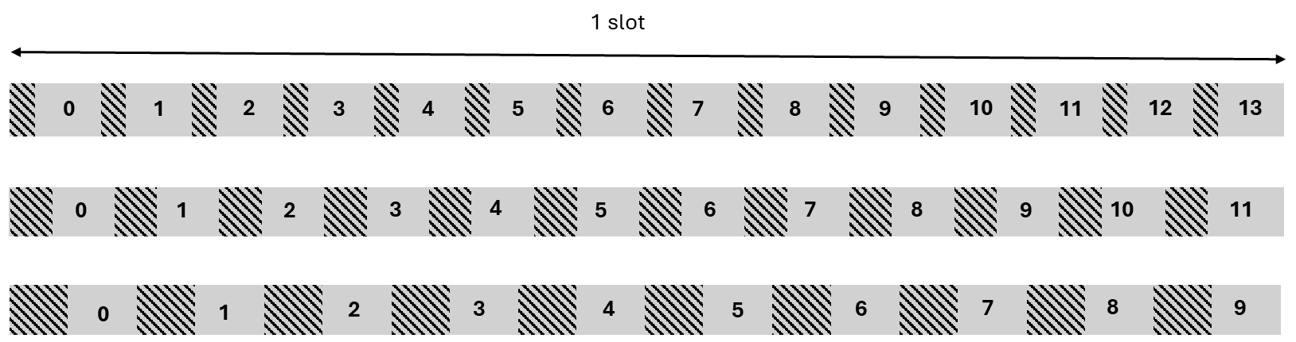
Figure 4: Examples of extended CP with reduced number of OFDM symbols per slot.
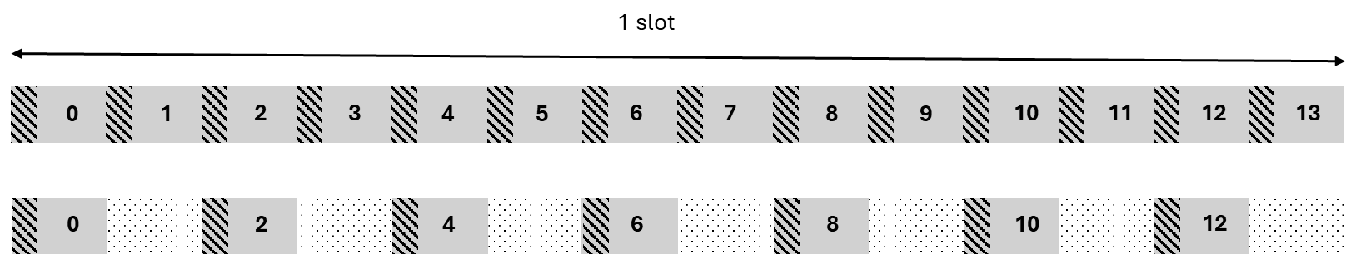
Figure 5: Example frame structure with symbol muting.
Figure 6 shows the RMSE of delay estimation as a function of the true target excess delay for a bistatic sensing scenario, considering multiple CP lengths at high SNR. In the considered setup, a subcarrier spacing of 120 kHz and an FFT size of 128 are assumed, which correspond to a sampling rate of 15.36 MHz and an OFDM symbol period of 8.3333 microseconds. Four CP configurations are considered, namely CP-1, CP-2, CP-3, and CP-4, with CP lengths of 8, 14, 21, and 28 samples, respectively, where one sample corresponds to 6.5104e-08 s. In this evaluation, attenuation due to propagation delay is not taken into account. Therefore, as long as the target excess delay remains within the corresponding CP length, delay-estimation RMSE remains low, whereas once the target excess delay exceeds the CP length, inter-symbol interference appears and the RMSE increases. The figure also shows that increasing the CP length shifts the onset of degradation to larger excess-delay values, which supports studying longer or equivalent CP / guard-based mechanisms for sensing scenarios with large excess delay.
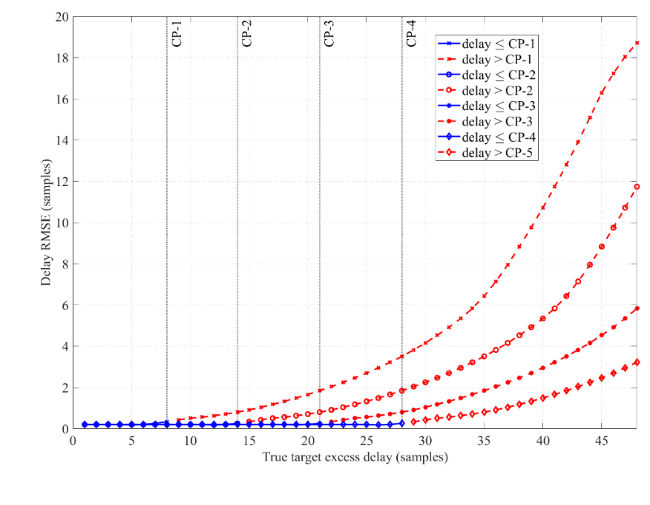
Figure 6: Example demonstration of target excess delay enhancement with respect to CP length.
Observation 12: In sensing scenarios with large monostatic or bistatic delay, the baseline guard interval may not be sufficient to avoid or mitigate ISI/ICI under the assumed sensing receiver processing. Mechanisms such as extended CP, reduced symbol count per slot, guard periods, and muted symbols can provide extended effective guard time for sensing while preserving, where possible, the baseline slot/frame timing.
Proposal 12: RAN1 should study mechanisms to provide extended effective guard time for sensing, including at least:
- Extended CP for sensing-related OFDM symbols;
- Reduced number of OFDM symbols within a slot to allow additional CP and/or guard time while preserving slot duration;
- Guard period before and/or after sensing RS symbols;
- Muted-symbol-based guard mechanisms.

SCS / symbol-duration options for sensing

SCS is closely related to frame structure because it determines OFDM symbol duration and, for a fixed number of subcarriers, the occupied bandwidth. Therefore, SCS directly affects sensing characteristics such as range resolution, Doppler/velocity resolution, maximum unambiguous range, maximum unambiguous velocity, and robustness to Doppler-induced ICI. As a result, a single SCS may not be uniformly optimal for all sensing scenarios and requirements (see Figure 7).

When the SCS is increased, the occupied bandwidth becomes larger for a fixed number of subcarriers, which improves range resolution. At the same time, the OFDM symbol duration becomes shorter. This reduces the coherent observation time for a fixed number of OFDM symbols and therefore degrades Doppler/velocity resolution. However, the shorter symbol duration also increases the maximum unambiguous Doppler/velocity range. In addition, a larger SCS reduces the normalized Doppler shift and hence improves robustness to Doppler-induced ICI, which can be beneficial in high-mobility sensing scenarios. The trade-off is that the maximum unambiguous sensing range is reduced as SCS increases. A smaller unambiguous range increases the likelihood that delayed echoes from more distant targets fold back into the observable range, which may appear as ambiguous detections or ghost targets.

In contrast, when the SCS is reduced, the OFDM symbol duration becomes longer, which improves Doppler/velocity resolution by enabling finer Doppler discrimination over the observation interval. A smaller SCS also increases the maximum unambiguous range, which can be beneficial for sensing scenarios requiring larger delay support. In particular, a larger unambiguous range reduces the probability that delayed target echoes wrap around into the observable delay region and appear as ghost targets. The trade-off is that, for a fixed number of subcarriers, the occupied bandwidth becomes smaller, which degrades range resolution. In addition, the maximum unambiguous Doppler/velocity range becomes smaller, and the waveform becomes less robust to Doppler-induced ICI.

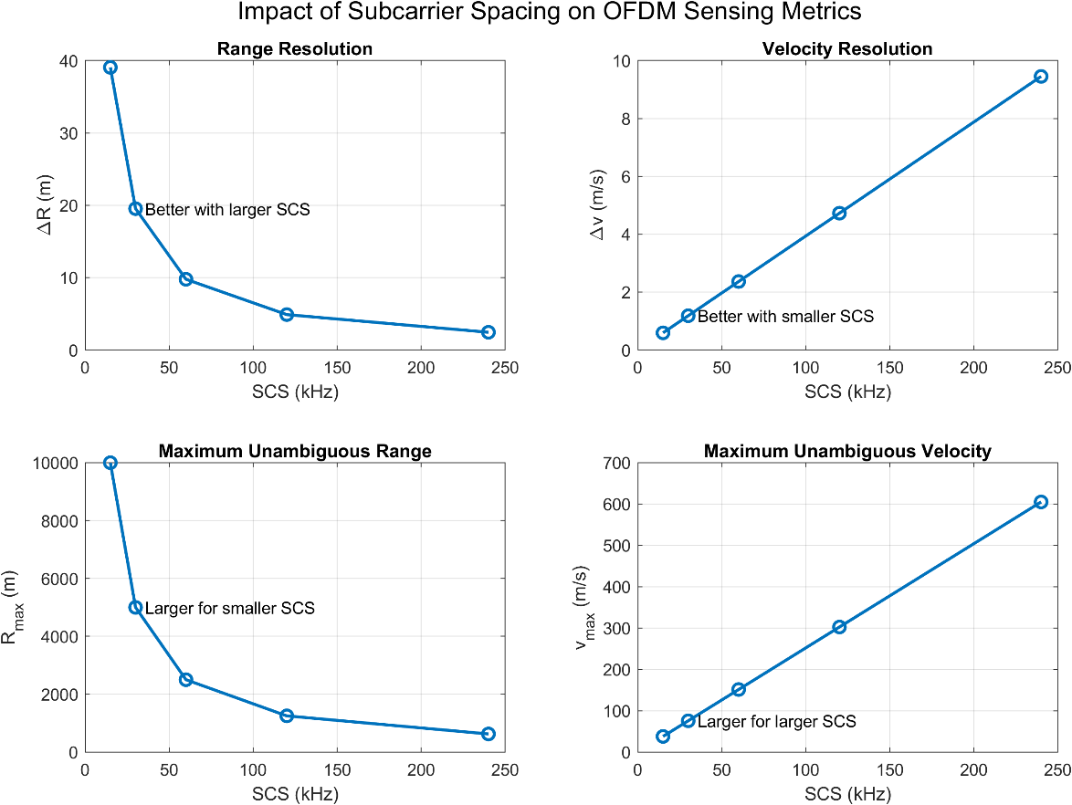
Figure 7: Impact of subcarrier spacing on OFDM sensing metrics.
The qualitative trade-offs in Table 1 assume, unless otherwise stated, fixed number of subcarriers and/or fixed number of OFDM symbols; when total bandwidth or total CPI duration is fixed, some trade-offs may differ.

Table 1: Qualitative impact of SCS on OFDM sensing metrics.
Aspect | Larger SCS | Smaller SCS
Occupied bandwidth (for fixed subcarrier count) | Increased occupied bandwidth | Reduced occupied bandwidth
Range resolution | Improved | Degraded
OFDM symbol duration | Shorter symbol duration | Longer symbol duration
Velocity / Doppler resolution | Coarser Doppler resolution | Finer Doppler resolution
Maximum unambiguous range | Reduced | Increased
Maximum unambiguous velocity | Increased | Reduced
Robustness to Doppler-induced ICI | Improved robustness | Reduced robustness

Accordingly, the choice of SCS introduces a fundamental sensing trade-off: larger SCS tends to favour range resolution, unambiguous velocity, and Doppler robustness, while smaller SCS tends to favour Doppler/velocity resolution, larger unambiguous range, and reduced risk of ghost-target generation caused by range ambiguity. This suggests that frame-structure study should not assume that the communication-side SCS choice is uniformly suitable for all sensing operating conditions. Instead, the SCS/symbol-duration study can be structured into at least three cases:
- Communication-aligned SCS, where sensing uses the same SCS/symbol duration as communication;
- Sensing-specific SCS, where sensing uses a different SCS/symbol duration;
- Mixed-numerology multiplexing, where sensing and communication resources with different SCS are multiplexed and aligned.

Observation 13: SCS and symbol duration are important frame-structure design parameters for sensing. Relevant study cases include communication-aligned SCS, sensing-specific SCS, and mixed-numerology multiplexing, since SCS affects range resolution, Doppler/velocity resolution, unambiguous range/velocity, Doppler robustness, and the risk of ambiguous detections such as ghost targets.

Proposal 13: RAN1 should study SCS/symbol-duration options for sensing, including at least:
- communication-aligned SCS, where sensing uses the same SCS/symbol duration as communication;
- sensing-specific SCS, where sensing uses a different SCS/symbol duration;
- mixed-numerology multiplexing, where sensing and communication resources with different SCS are multiplexed and aligned.

Sensing-resource time-domain organization

With the communication-side frame-structure baseline established, frame-structure study should also address how sensing resources are organized in time over the 6GR communication frame structure. Relevant aspects include sensing occasion structure, placement and duration of sensing resources, repetition across symbols/slots/subframes/frames, and CPI / observation interval formation over one or more sensing occasions. These aspects affect coherent and non-coherent processing, delay/Doppler estimation performance, sensing overhead, and coexistence with communication.

In particular, sensing occasion structure should clarify where sensing resources are placed relative to the communication timing structure and how long such sensing occasions last. Repetition pattern across symbols, slots, subframes, and frames affects coherent integration and non-coherent processing gain, and therefore influences sensing performance under different operating conditions. CPI / observation interval formation is also important because delay and Doppler estimation may rely on measurements collected over one or more sensing occasions rather than within a single isolated symbol or slot. Therefore, frame-structure study should make explicit how the sensing observation interval is formed over time relative to the 6GR communication frame structure.

Observation 14: Sensing-resource organization over the 6GR communication frame structure is a key frame-structure aspect, including sensing occasion placement/duration, repetition pattern, and CPI / observation interval formation. These aspects directly affect delay/Doppler estimation, overhead, and coexistence with communication.

Proposal 14: RAN1 should study sensing-resource time-domain organization over the 6GR communication frame structure, including at least:
- sensing occasion structure, including placement and duration of sensing resources;
- repetition pattern across symbols/slots/subframes/frames for coherent or non-coherent processing;
- CPI / observation interval formation over one or more sensing occasions for delay/Doppler estimation.

Frequency-domain comb size and resource mapping for sensing RS/resources

In addition to time-domain organization, frame-structure study should also address how sensing RS/resources are organized in frequency relative to the 6GR communication resource grid. Even when the agreed CP-OFDM waveform starting point is preserved, sensing performance can depend strongly on how sensing RS/resources are mapped on the frequency-domain grid. In particular, frequency-domain comb size, sensing bandwidth occupation, and resource mapping relative to the 6GR communication resource grid may affect delay ambiguity, bandwidth usage, sensing overhead, and coexistence with communication.

A sensing RS comb size different from communication RS may be beneficial depending on the sensing objective and operating assumptions. Likewise, sensing bandwidth occupation may be contiguous or distributed in frequency, and the choice can affect sensing resolution, resource overhead, and integration with the communication grid. Therefore, these aspects should be explicitly studied rather than being implicitly assumed to follow communication RS design in all cases.

Observation 15: For sensing RS/resources based on the agreed CP-OFDM starting point, frequency-domain comb size and resource mapping relative to the 6GR communication grid are important frame-structure aspects. These aspects may affect sensing bandwidth occupation, sensing overhead, and coexistence with communication.

Proposal 15: RAN1 should study frequency-domain comb-size and resource-mapping aspects for sensing RS/resources, including at least:
- sensing RS comb size, including comb size different from communication RS where applicable;
- sensing bandwidth occupation, including contiguous or distributed frequency-domain allocation;
- frequency-domain mapping of sensing resources relative to the 6GR communication resource grid.

Conclusions
The following proposals are made in this contribution:

Proposal 1: RAN1 should study 6G ISAC-specific waveform and/or frame-structure enhancements relative to the agreed CP-OFDM waveform and 6GR communication frame-structure starting points. Further consideration of such enhancements should be limited to cases where the agreed starting points show limitations or gaps in meeting the relevant sensing requirements/KPIs or communication-integration requirements for the considered sensing mode, scenario, and operating assumptions.

Proposal 2: RAN1 should compare 6G ISAC waveform and frame-structure candidates using a common comparison basis, including at least:
- sensing mode and scenario;
- sensing signal/resource configuration;
- RE mapping and sensing resource ratio/overhead;
- observation interval/CPI;
- numerology, bandwidth, and transmit power/energy;
- receiver processing;
- channel and interference model;
- communication integration impact, including coexistence and multiplexing.

Proposal 3: RAN1 can use theoretical waveform-characteristics analysis as one component of 6G ISAC waveform and frame-structure study, but not as the only basis for evaluating sensing waveform or frame-structure candidates. Link-level study should be used to evaluate point-to-point sensing performance under defined channel and receiver assumptions, and system-level study should be considered where system-level sensing performance, overhead, or communication-integration impact is to be assessed.

Proposal 4: For LLS and/or SLS evaluation of waveform and frame-structure candidates, RAN1 should study metrics including at least:
- delay/range accuracy;
- Doppler/velocity accuracy;
- missed-detection probability, where applicable;
- false-alarm probability, where applicable;
- robustness to SNR, Doppler, timing offset, and frequency offset where relevant;
- sensing overhead/resource efficiency;
- communication impact, including coexistence and multiplexing effect.

Proposal 5: For theoretical waveform-characteristics analysis, RAN1 should study metrics including at least:
- PAPR;
- ACLR/OOBE;
- ambiguity-function main-lobe and side-lobe characteristics;
- PSLR;
- ISLR;
- auto-correlation and/or cross-correlation characteristics;
- maximum unambiguous delay/range and Doppler/velocity, where applicable.

Proposal 6: RAN1 should study the necessity/benefits and the applicable scenarios at least for the following enhancements from perspective of CP-OFDM waveform for 6G ISAC:
- Low PAPR
- Low ACLR/OOBE
- Ambiguity function characteristics
- Auto- or Cross-correlation
- Time-domain and/or frequency-domain processing of sensing signals/resources
- Low sensing RS overhead (e.g., guard band reuse)
- Resilience to ISI (Inter-Symbol Interference) and/or ICI (Inter-Carrier Interference)
- Full duplex operation

Proposal 7: For time-domain and/or frequency-domain processing of sensing signals/resources, RAN1 should study at least:
- where the processing is applied, e.g., transmitter side, receiver side, or both;
- whether the processing is applied to sensing RS/sequence generation, RE/resource mapping, OFDM-symbol-level samples, and/or receiver-side sensing processing;
- required receiver knowledge or configuration of the processing;
- impact on CP-OFDM compatibility, communication coexistence, and baseband implementation complexity.

Proposal 8: For pulse-type and FMCW/LFM-type sensing waveform/signal candidates, RAN1 should study how such candidates are introduced relative to the agreed CP-OFDM waveform starting point, including at least:
- realization within CP-OFDM-based signal/resource design;
- multiplexing with CP-OFDM communication or sensing resources;
- use of dedicated sensing resources where a dedicated waveform/signal structure is assumed.

Proposal 9: For pulse-type and FMCW/LFM-type sensing waveform/signal candidates, RAN1 should study generation methods, including at least:
- CP-OFDM-based generation using frequency-domain signal/resource design;
- CP-OFDM-based generation using large SCS;
- sequence-based generation, e.g., enhanced ZC or chirp-like sequences;
- DFT-s-OFDM-based generation;
- dedicated FMCW/LFM or FMBW generation where applicable.

Proposal 10: RAN1 should study the potential benefits of specifying waveform/signal aspects for TRP-TRP bistatic sensing, TRP monostatic sensing, and where UE monostatic sensing is studied, UE monostatic sensing, instead of assuming that the sensing waveform is fully implementation-specific. The study should consider at least interoperability, resource/timing coordination, receiver knowledge, interference handling, reuse of the same waveform family across sensing modes, and coexistence with communication.
Proposal 11: RAN1 should study whether and under what conditions 6GR communication data can be used for sensing. The study should consider at least applicable sensing modes and scenarios, required receiver knowledge of the communication data/signal, impact of data randomness on sensing performance, impact on communication reception, and whether deterministic sensing components or sensing RS/resources can be multiplexed with communication data to improve sensing reliability.

Proposal 12: RAN1 should study mechanisms to provide extended effective guard time for sensing, including at least:
- Extended CP for sensing-related OFDM symbols;
- Reduced number of OFDM symbols within a slot to allow additional CP and/or guard time while preserving slot duration;
- Guard period before and/or after sensing RS symbols;
- Muted-symbol-based guard mechanisms.

Proposal 13: RAN1 should study SCS/symbol-duration options for sensing, including at least:
- communication-aligned SCS, where sensing uses the same SCS/symbol duration as communication;
- sensing-specific SCS, where sensing uses a different SCS/symbol duration;
- mixed-numerology multiplexing, where sensing and communication resources with different SCS are multiplexed and aligned.

Proposal 14: RAN1 should study sensing-resource time-domain organization over the 6GR communication frame structure, including at least:
- sensing occasion structure, including placement and duration of sensing resources;
- repetition pattern across symbols/slots/subframes/frames for coherent or non-coherent processing;
- CPI / observation interval formation over one or more sensing occasions for delay/Doppler estimation.

Proposal 15: RAN1 should study frequency-domain comb-size and resource-mapping aspects for sensing RS/resources, including at least:
- sensing RS comb size, including comb size different from communication RS where applicable;
- sensing bandwidth occupation, including contiguous or distributed frequency-domain allocation;
- frequency-domain mapping of sensing resources relative to the 6GR communication resource grid.

References
- RP-260282, "Revised SID: Study on 6G Radio", RAN#111, Fukuoka, Japan, March 2026.
- 3GPP TR 38.765, "Study on Integrated Sensing And Communication (ISAC) for NR" (Release 20), 2026-02.
- R1-2601696, "Feature Lead summary #5 on 6G waveform", Moderator (Nokia), Gothenburg, Sweden, February 2026.
- R1-2509625, "FL summary for Frame Structure (Final)", Moderator (CMCC), Dallas, USA, November 2025.
[5] R1-2601752, “Report of RAN1#124b meeting,” RAN1 Chair, Malta, MT, April 2026.

